Trapezoidal-Based Prismoid

Definition
# Source: AI Source: Provided by: [Data Path: Persons Table -> ID Column: 1, Name_En Column: Motasem Essam] -> From: [ChatGPT] on [7/25/2026]
A Trapezoidal-Based Prismoid is a type of quadrilateral prismoid whose two parallel bases are trapezoids.
The upper and lower bases are trapezoidal polygons positioned in two parallel planes. They may differ in size, and their corresponding vertices are connected by four lateral faces.
The trapezoidal bases have one pair of parallel sides under the usual definition of a trapezoid. The lateral faces are quadrilaterals, which may be trapezoids or parallelograms depending on the arrangement of the vertices.

Geometric Structure
# Source: AI Source: Provided by: [Data Path: Persons Table -> ID Column: 1, Name_En Column: Motasem Essam] -> From: [ChatGPT] on [7/25/2026]
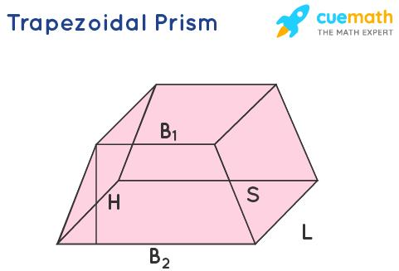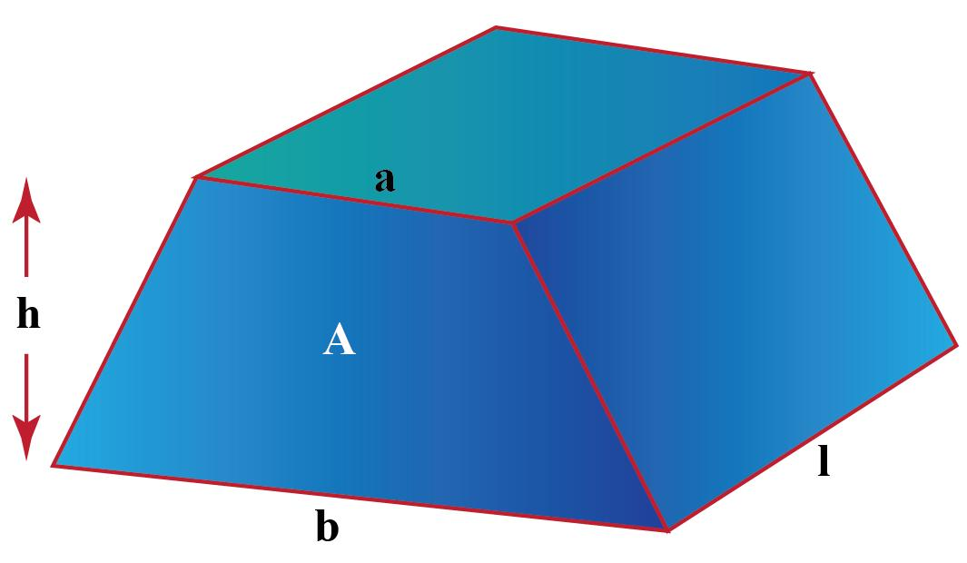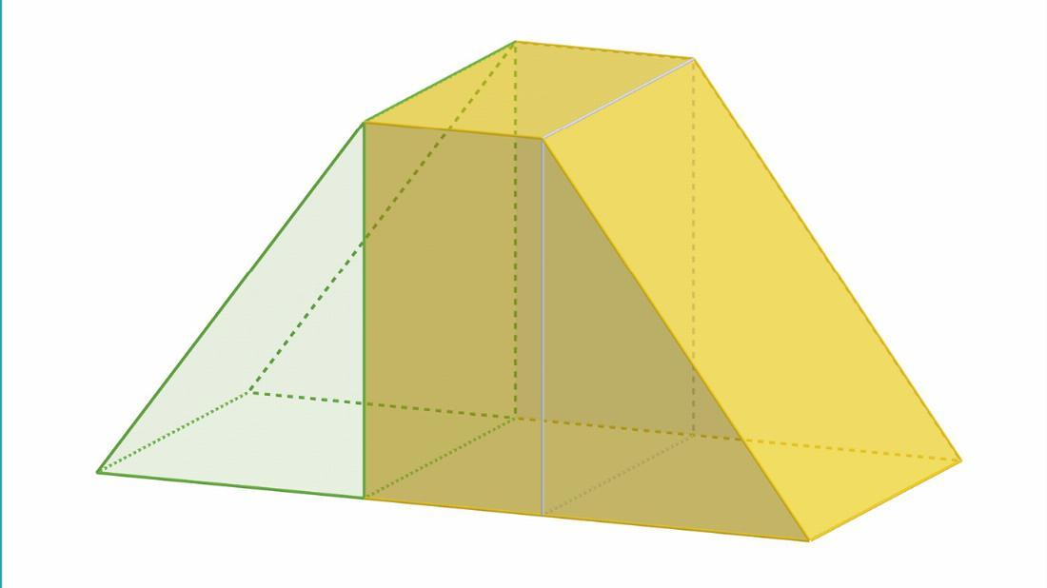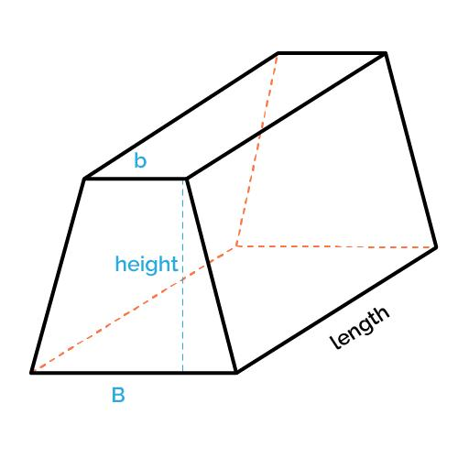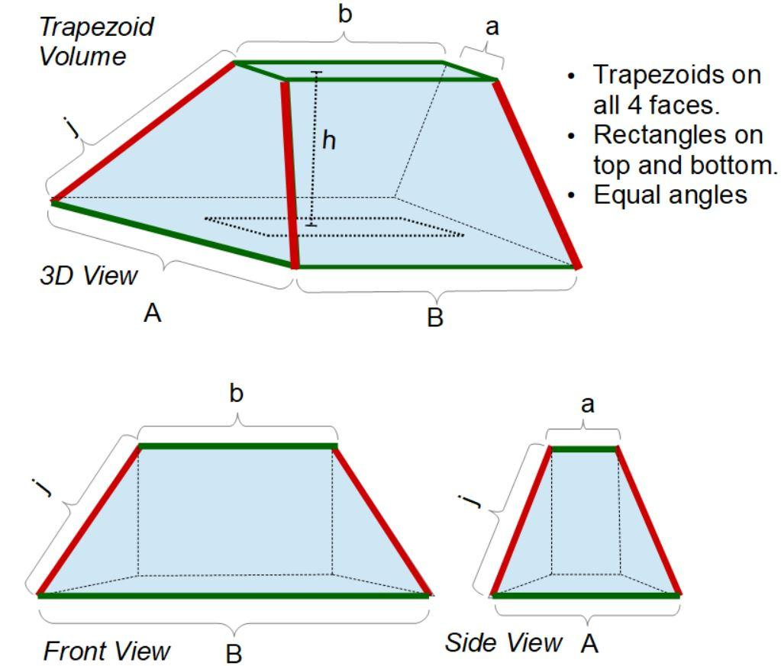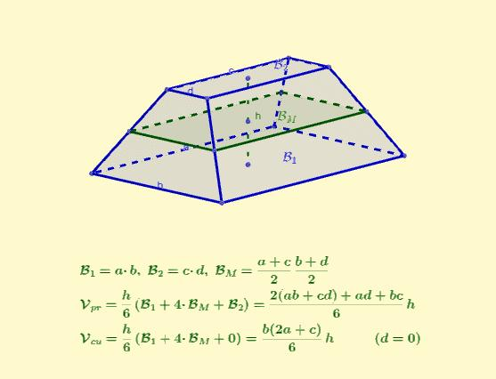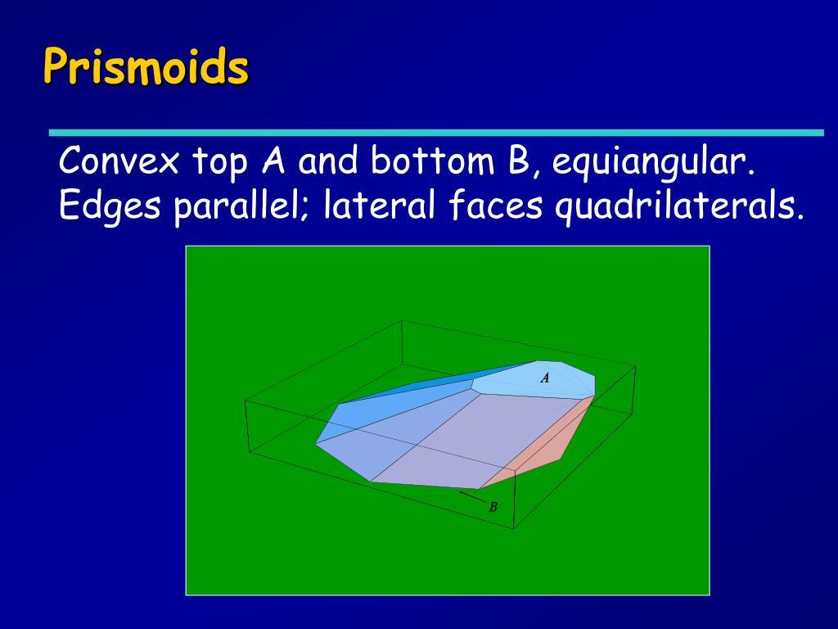
A trapezoidal-based prismoid consists of:
- Lower Base: A trapezoid forming the bottom face.
- Upper Base: A trapezoid forming the top face, parallel to the lower base.
- Lateral Faces: Four quadrilateral faces connecting the corresponding edges of the two bases.
- Lateral Edges: Four edges connecting corresponding vertices of the upper and lower bases.
- Height: The perpendicular distance between the two parallel base planes.

Face Composition
# Source: AI Source: Provided by: [Data Path: Persons Table -> ID Column: 1, Name_En Column: Motasem Essam] -> From: [ChatGPT] on [7/25/2026]
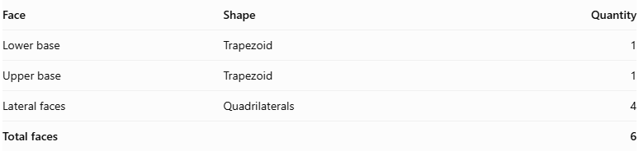
Face | Shape | Quantity
Lower base | Trapezoid | 1
Upper base | Trapezoid | 1
Lateral faces | Quadrilaterals | 4
Total faces |  | 6
The solid also contains:
- 12 edges
- 8 vertices
- 2 parallel trapezoidal bases
- 4 lateral quadrilateral faces

Mathematical Properties
# Source: AI Source: Provided by: [Data Path: Persons Table -> ID Column: 1, Name_En Column: Motasem Essam] -> From: [ChatGPT] on [7/25/2026]
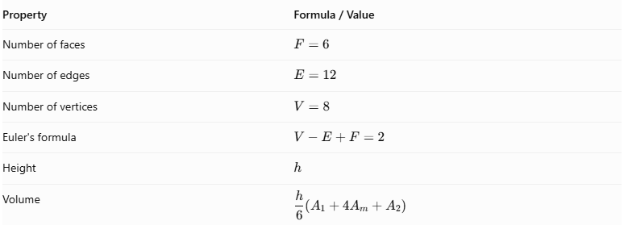
Property | Formula / Value
Number of faces | $$F=6$$
Number of edges | $$E=12$$
Number of vertices | $$V=8$$
Euler's formula | $$V-E+F=2$$
Height | $$h$$
Volume | $$displaystyle\frac{h}{6}(A_{1}+4A_{m}+A_{2})$$
Prismoidal Volume Formula:
$$\boxed{V=\frac{h}{6}(A_{1}+4A_{m}+A_{2})}$$
Where:
- $V$ = Volume of the prismoid.
- $h$ = Perpendicular distance between the two bases.
- $A_{1}$ = Area of the lower trapezoidal base.
- $A_{2}$ = Area of the upper trapezoidal base.
- $A_{m}$ = Area of the cross-section halfway between the two bases and parallel to them.
Area of a trapezoid:
$$A=\frac{1}{2}(a+b)h_{t}$$
Where:
- $a$ = Length of the first parallel side.
- $b$ = Length of the second parallel side.
- $h_{t}$ = Perpendicular height of the trapezoid.

Geometric Characteristics
# Source: AI Source: Provided by: [Data Path: Persons Table -> ID Column: 1, Name_En Column: Motasem Essam] -> From: [ChatGPT] on [7/25/2026]
- Trapezoidal Bases: Both bases have trapezoidal shapes.
- Parallel Base Planes: The upper and lower bases lie in parallel planes.
- Four Lateral Faces: The bases are connected by four quadrilateral lateral faces.
- Variable Base Dimensions: The upper trapezoid may have different dimensions from the lower trapezoid.
- Variable Orientation: The upper base may be positioned differently relative to the lower base, provided the lateral faces remain planar.
- Prismoidal Structure: The solid has six faces, twelve edges, and eight vertices.
- Midsection: A cross-section parallel to the bases can be taken halfway between them and used in the prismoidal volume formula.

Types of Trapezoidal-Based Prismoids
# Source: AI Source: Provided by: [Data Path: Persons Table -> ID Column: 1, Name_En Column: Motasem Essam] -> From: [ChatGPT] on [7/25/2026]
The following are possible geometric configurations based on the shapes and arrangements of their trapezoidal bases.
- Right Trapezoidal-Based Prismoid: A configuration in which the lateral direction is perpendicular to the base planes.
- Oblique Trapezoidal-Based Prismoid: A configuration in which the lateral direction is inclined relative to the perpendicular direction of the base planes.
- Symmetric Trapezoidal-Based Prismoid: A configuration with a symmetric arrangement of the trapezoidal bases.
- Irregular Trapezoidal-Based Prismoid: A configuration with trapezoidal bases of different dimensions or an irregular arrangement of corresponding vertices.
These describe possible configurations rather than a universally standardized classification.

Constructing a Trapezoidal-Based Prismoid

Geometric Instruments Used
# Source: AI Source: Provided by: [Data Path: Persons Table -> ID Column: 1, Name_En Column: Motasem Essam] -> From: [ChatGPT] on [7/25/2026]
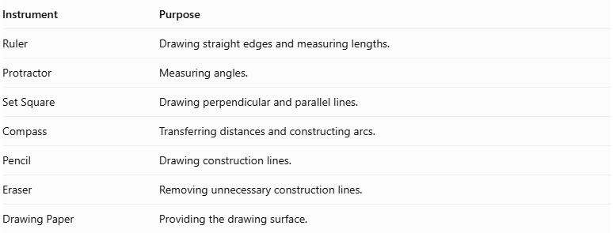
Instrument | Purpose
Ruler | Drawing straight edges and measuring lengths.
Protractor | Measuring angles.
Set Square | Drawing perpendicular and parallel lines.
Compass | Transferring distances and constructing arcs.
Pencil | Drawing construction lines.
Eraser | Removing unnecessary construction lines.
Drawing Paper | Providing the drawing surface.

Instrument-Based Construction Procedures
# Source: AI Source: Provided by: [Data Path: Persons Table -> ID Column: 1, Name_En Column: Motasem Essam] -> From: [ChatGPT] on [7/25/2026]
The construction can be performed using three main methods.

Method 1: Construction Using a Geometric Net
# Source: AI Source: Provided by: [Data Path: Persons Table -> ID Column: 1, Name_En Column: Motasem Essam] -> From: [ChatGPT] on [7/25/2026]
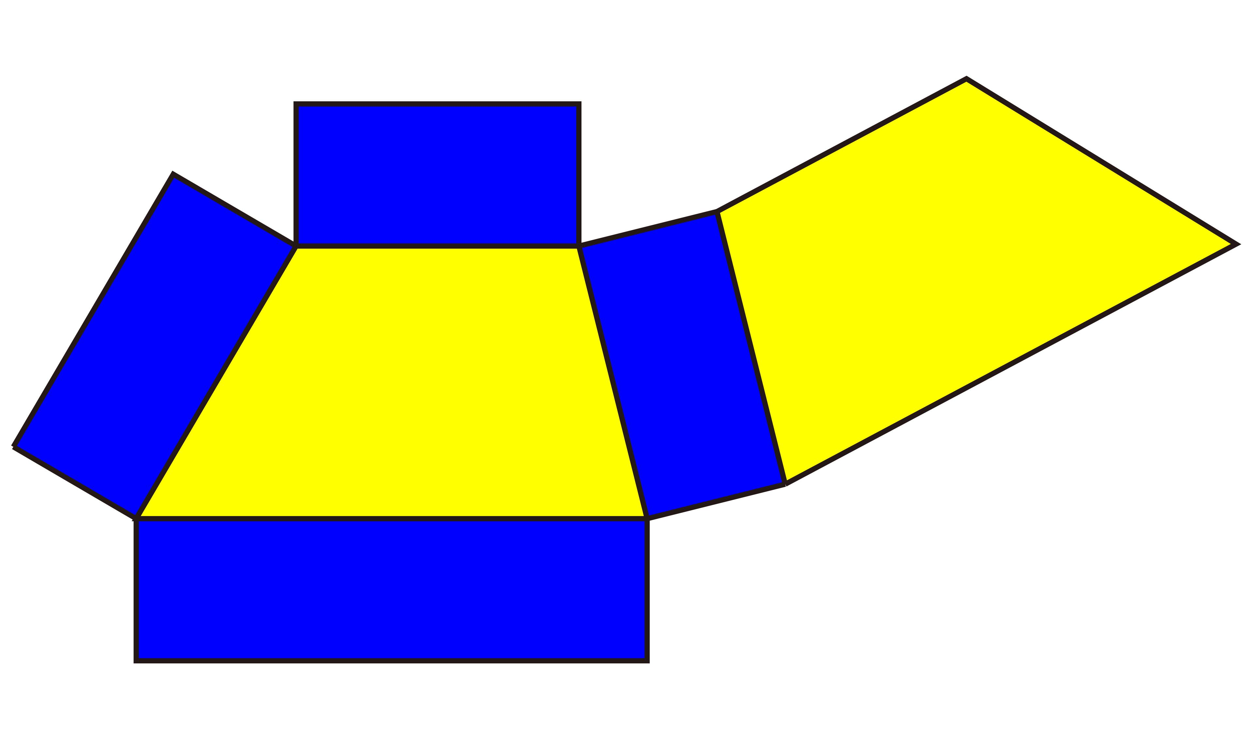
- Draw the lower trapezoidal base on the drawing paper.
- Draw the upper trapezoidal base with its required dimensions.
- Construct four lateral quadrilateral faces using the required edge lengths.
- Arrange the four lateral faces around the lower base.
- Attach the upper base to the appropriate edges of the lateral faces.
- Check that all corresponding edges have matching lengths.
- Cut out the complete geometric net.
- Fold the lateral faces along their boundary lines.
- Bring the upper and lower bases into their final positions.
- Join the matching edges of the lateral faces.
- Secure the edges using glue or adhesive.
- Check that the resulting solid has two trapezoidal bases and four lateral faces.

Method 2: Construction Using Two Parallel Trapezoidal Bases
# Source: AI Source: Provided by: [Data Path: Persons Table -> ID Column: 1, Name_En Column: Motasem Essam] -> From: [ChatGPT] on [7/25/2026]
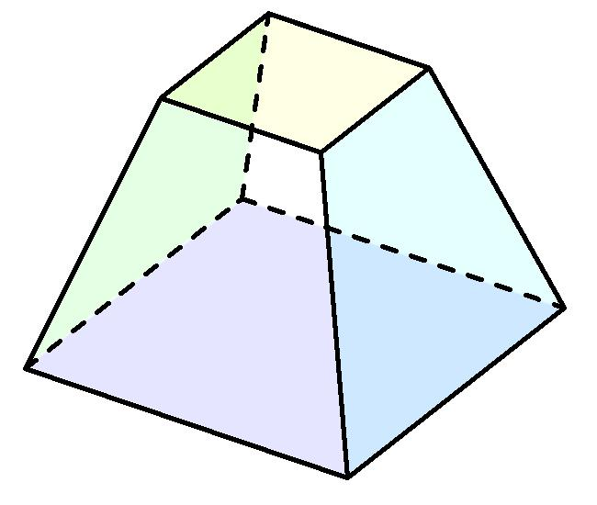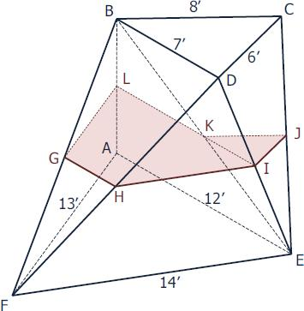
- Draw the lower trapezoidal base $ABCD$.
- Draw a second trapezoid $A'B'C'D'$ above the first one.
- Ensure that the two trapezoids lie in parallel planes.
- Position the upper trapezoid according to the required dimensions and orientation.
- Connect vertex $A$ to vertex $A'$.
- Connect vertex $B$ to vertex $B'$.
- Connect vertex $C$ to vertex $C'$.
- Connect vertex $D$ to vertex $D'$.
- Complete the four lateral quadrilateral faces.
Important: The upper trapezoid cannot be positioned arbitrarily. Its vertices must be arranged so that all four lateral quadrilaterals are planar.

Method 3: Construction Through Parallel Cross-Sections
# Source: AI Source: Provided by: [Data Path: Persons Table -> ID Column: 1, Name_En Column: Motasem Essam] -> From: [ChatGPT] on [7/25/2026]
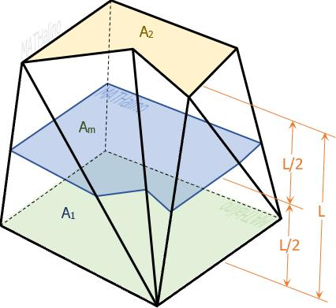
- Draw the lower trapezoidal base.
- Draw the upper trapezoidal base above it.
- Establish the perpendicular height between the two base planes.
- Divide the height into several equal intervals.
- Draw intermediate cross-sections parallel to the two bases.
- Determine the positions of the intermediate vertices according to the required geometry.
- Connect corresponding vertices between successive cross-sections.
- Complete the lateral faces and outline the final three-dimensional solid.

Related Geometric Solids
# Source: AI Source: Provided by: [Data Path: Persons Table -> ID Column: 1, Name_En Column: Motasem Essam] -> From: [ChatGPT] on [7/25/2026]
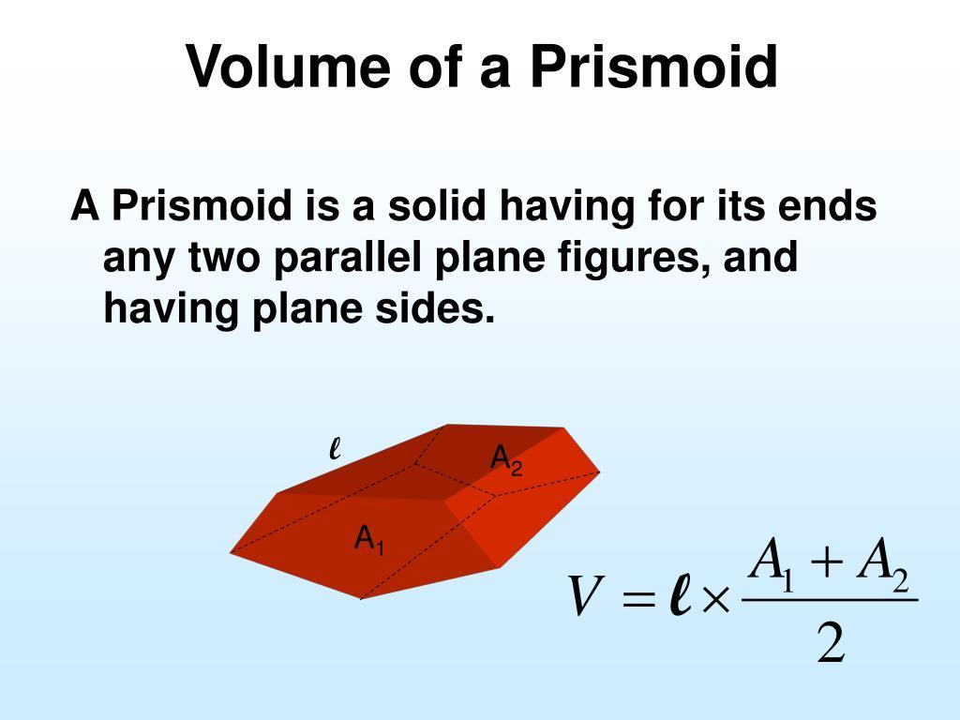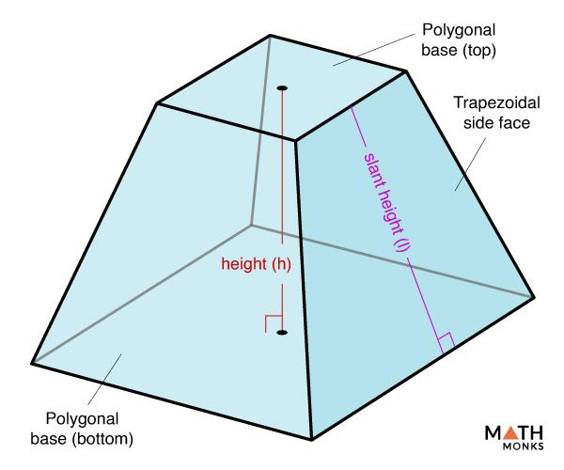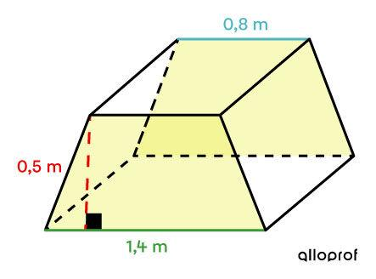
- Trapezoidal Prism: A solid with two congruent, parallel trapezoidal bases and four lateral faces.
- Trapezoidal Pyramid Frustum: A solid formed by cutting a trapezoidal pyramid with a plane parallel to its base.
- Quadrilateral Prismoid: A broader category of solids with two quadrilateral bases in parallel planes.
- Parallelogram-Based Prismoid: A quadrilateral prismoid whose bases are parallelograms.

Main Classification
# Source: AI Source: Provided by: [Data Path: Persons Table -> ID Column: 1, Name_En Column: Motasem Essam] -> From: [ChatGPT] on [7/25/2026]
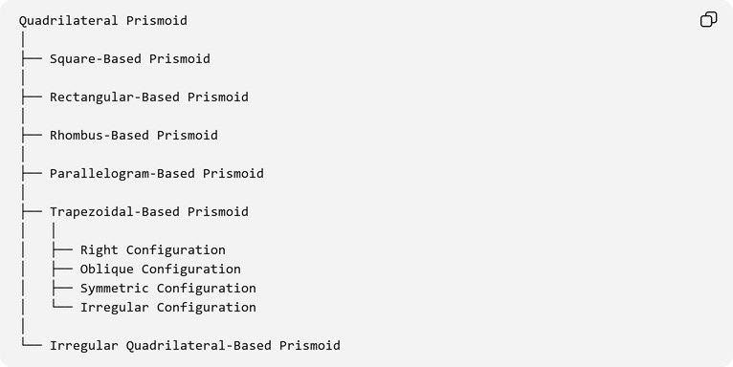
Quadrilateral Prismoid
│
├── Square-Based Prismoid
│
├── Rectangular-Based Prismoid
│
├── Rhombus-Based Prismoid
│
├── Parallelogram-Based Prismoid
│
├── Trapezoidal-Based Prismoid
│ │
│ ├── Right Configuration
│ ├── Oblique Configuration
│ ├── Symmetric Configuration
│ └── Irregular Configuration
│
└── Irregular Quadrilateral-Based Prismoid

Key Points
# Source: AI Source: Provided by: [Data Path: Persons Table -> ID Column: 1, Name_En Column: Motasem Essam] -> From: [ChatGPT] on [7/25/2026]
- A trapezoidal-based prismoid has two parallel trapezoidal bases.
- The upper and lower bases may have different dimensions.
- It contains four lateral quadrilateral faces.
- It has six faces, twelve edges, and eight vertices.
- Its height is the perpendicular distance between the base planes.
- Its volume can be calculated using the prismoidal formula.
- The arrangement of the vertices must ensure that the lateral faces are planar.

Conclusion
# Source: AI Source: Provided by: [Data Path: Persons Table -> ID Column: 1, Name_En Column: Motasem Essam] -> From: [ChatGPT] on [7/25/2026]
A Trapezoidal-Based Prismoid is a quadrilateral prismoid characterized by two parallel trapezoidal bases connected by four lateral quadrilateral faces. Its structure allows variations in base dimensions, orientation, and lateral geometry. It is an important example of a prismoid and demonstrates how trapezoidal polygons can form the parallel bases of three-dimensional geometric solids.

